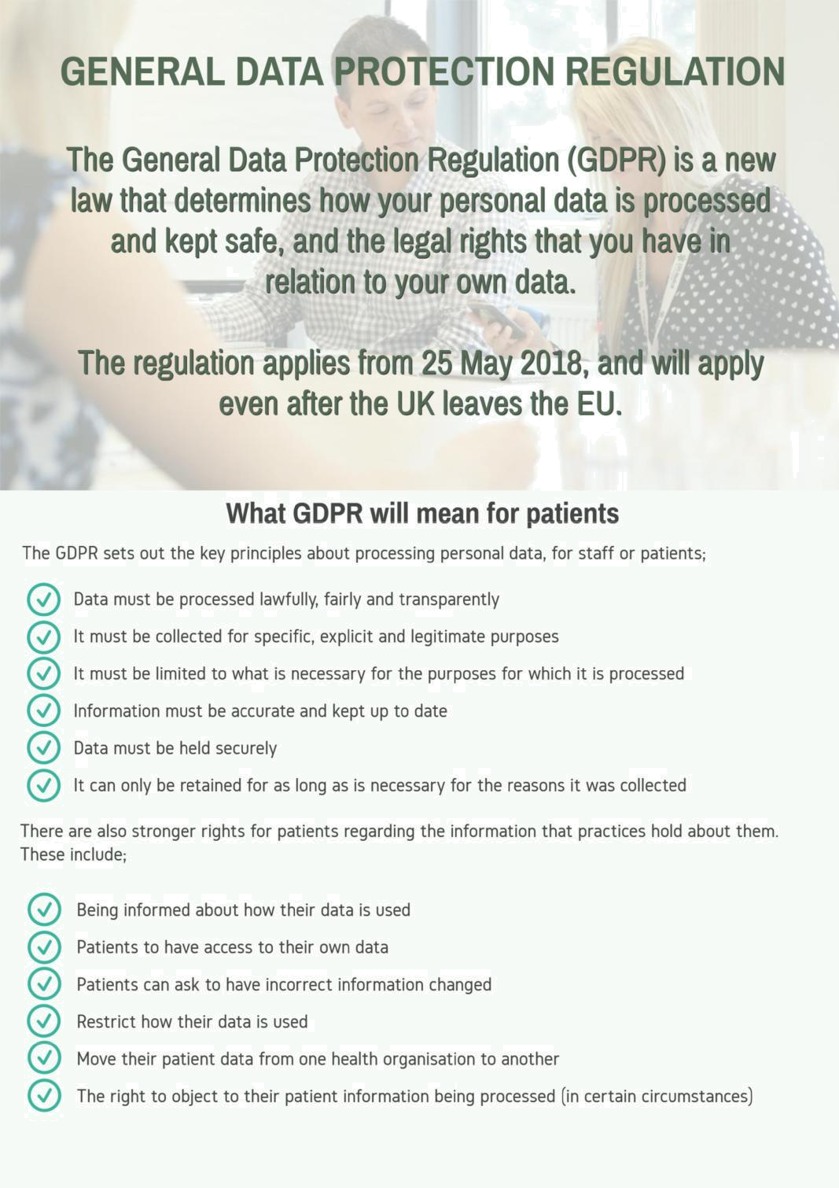
HESA Medical Centre

What is GDPR?

GDPR stands for General Data Protection Regulations and is a new piece of legislation that will supersede the Data Protection Act. It will not only apply to the UK and EU; it covers anywhere in the world in which data about EU citizens is processed.

The GDPR is similar to the Data Protection Act (DPA) 1998 (which the practice already complies with), but strengthens many of the DPA’s principles. The main changes are:

- Practices must comply with subject access requests

- Where we need your consent to process data, this consent must be freely given, specific, informed and unambiguous

- There are new, special protections for patient data

- The Information Commissioner’s Office must be notified within 72 hours of a data breach

- Higher fines for data breaches –

What is ‘patient data’?

Patient data is information that relates to a single person, such as his/her diagnosis, name, age, earlier medical history etc.

What is consent?

Consent is permission from a patient – an individual’s consent is defined as “any freely given specific and informed indication of his wishes by which the data subject signifies his agreement to personal data relating to him being processed.”

The changes in GDPR mean that we must get explicit permission from patients when using their data. This is to protect your right to privacy, and we may ask you to provide consent to do certain things, like contact you or record certain information about you for your clinical records.

Individuals also have the right to withdraw their consent at any time.

Contact us

Scan this code with your

mobile for more on GDPR

Dr Z Nasir & Dr R Mubarik

HESA Medical Centre
52 STATION ROAD
HAYES
UB3 4DD
http://www.hesamedicalcentre.co.uk/

